**Library Module – S tatic Library**

**1. Create 3 files as below. Let cal_utility.c, .h files be part of the library**

**· libapplication.c – will contain main() and will invoke functions in cal_utility.c**

Created a libapplication.c file that contains main() and invoking add(), sub() functions in cal_utility.c.

**· cal_utility.c – will contain atleast 2 or more functions [ You may add definitions of the functions in this file ]**

Created a cal_utility.c file containing definitions of add() and sub() functions.

Output: The code in cal_utility.c

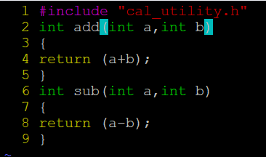

**· cal_utility.h – will contain the extern declarations/prototypes of the functions in cal_utility.c**

Created a cal_utility.h file containing prototypes of the functions in cal_utility.

Output: The code in cal_utility.

**2. Refer the steps for static library based application and create a static library application using above set of files.**



ar rcs <library name> <list of .o files>

where

r - insert a file into an archive

c - create an archive

s - write an object file index into an archive



**3. Execute the application created in step #2**

